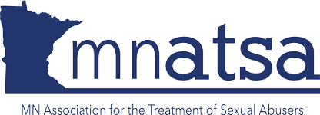
_________________________________________________________________________________________________________________________

Jacob Wetterling Scholarship
The Jacob Wetterling Scholarship provides an opportunity for two individuals who work primarily with victims of sexual abuse to attend the
2021 MnATSA Conference
The Minnesota Chapter of the Association for the Treatment of Sexual Abusers (MnATSA) is the state chapter of the Association for the Treatment of Sexual Abusers (ATSA). MnATSA is a non-profit interdisciplinary organization committed to the prevention of sexual abuse in all its forms through effective management and treatment of those who have committed sexual offenses.
In 2017, the MnATSA Education and Public Policy Committee announced the creation of two Jacob Wetterling Scholarships. These scholarships were created to promote professional relationships across organizations and to provide opportunities for individuals who work primarily with victims of sexual abuse to attend the MnATSA conference. The scholarships include a conference registration for up to three days valued at up to $300. The scholarships do not include lodging or other expenses.
Whether you are familiar with MnATSA or have never attended our conference, please consider submitting a scholarship application. The conference dates are April 21-23, 2021 via Zoom/Whova.
Please visit www.mnatsa.org for more information on past conferences and the organization itself. Thank you for all you do to advance the mission of preventing sexual violence.

Your submission should include:
- Name:
- Organization:
- Address:
- Date of Application:
- Contact Name:
- Telephone:
- e-mail:

Briefly describe your organization, the populations with which you work, and why it would be beneficial for you or your staff to attend the MnATSA Conference. If possible, please include your organization’s mission statement and any website address associated with your organization.

Please submit this application by January 15, 2021.
The MnATSA board will review all applications at the February board meeting
and notify the scholarship winners by February 12, 2021.
Submit your proposal to: 4mnatsa@gmail.com

