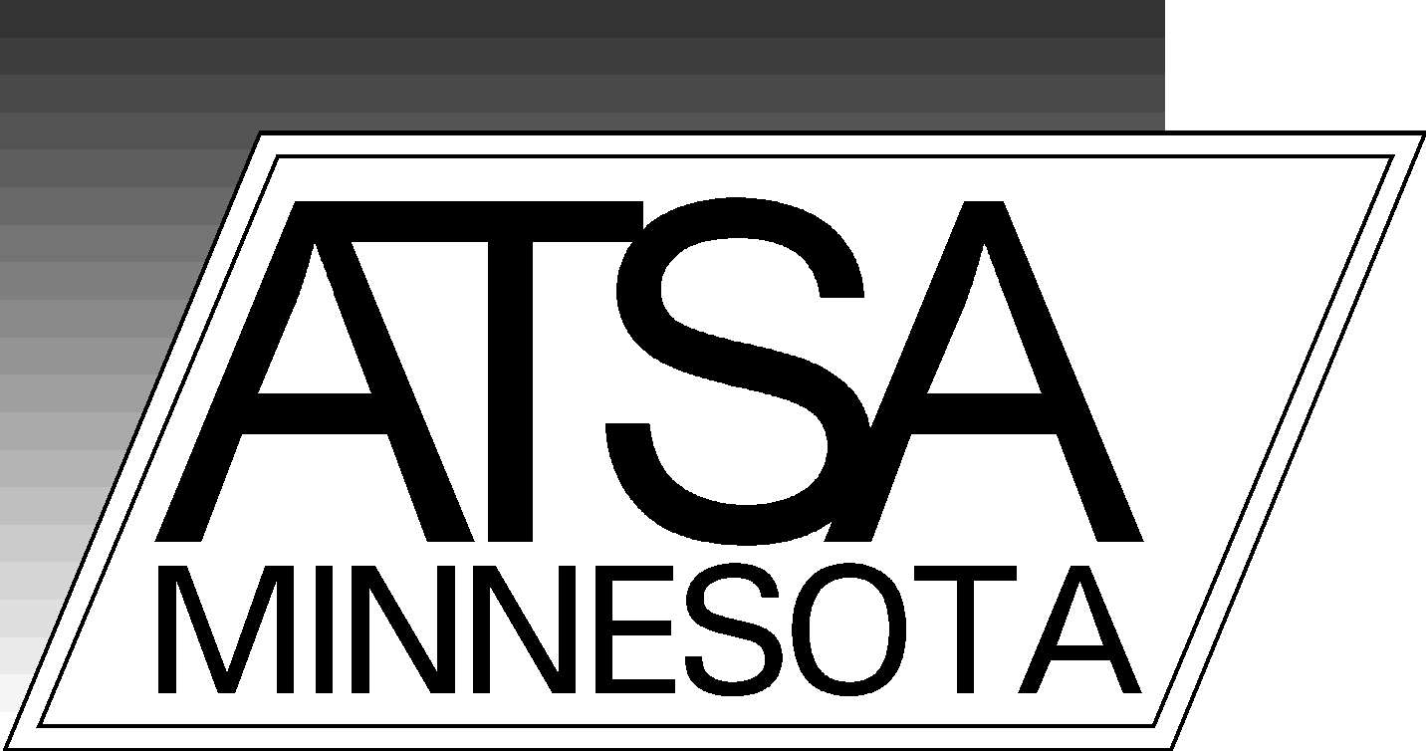

CURRENT BOARD MEMBERS

Amber Lindeman, President
Marie Grace, Treasurer
Katie Holmgren, Secretary

Michael Cheney
Katherine Farrington
Stephen Huot
Riki Kravitz
Kathryn Lockie
Rosemary Munns
Paul Rodriguez

MISSION STATEMENT

MnATSA is dedicated to a multidisciplinary promotion of education, research and professional intervention regarding sexual abuse issues. This state chapter is organized to acknowledge and promote the national and international programs of the Association for the Treatment of Sexual Abusers.

CALENDAR of EVENTS

- Monthly Board Meeting – 1st Friday of every month
- April 21-23, 2021 - Annual MnATSA Conference
- April 23, 2021 - Annual membership meeting (at conference)

JOIN TODAY AND BECOME PART OF AN EXCITING ORGANIZATION!
You must be a current member of ATSA to join MnATSA.
If you work outside of Minnesota, are an ATSA member, and wish to join MnATSA you may join at the affiliate membership level. This level entitles you to chapter membership rights, but with no voting rights or ability to join the board.

return this portion return this portion

MEMBERSHIP INVOICE

Yearly Membership (January - December 2020): $15.00 NEW Full member
RENEWAL Affiliate member

Name: I am a current ATSA member

Organization:

Address:

City, State, Zip Code:

Telephone # e-mail:

Please remit the lower portion of this invoice and your check (payable to MnATSA) to:

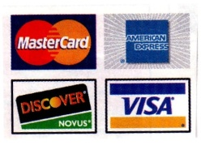
MnATSA, PO Box 221, Lake Elmo MN 55042

If you prefer to pay with a credit card please go to www.mnatsa.org
or e-mail 4mnatsa@gmail.com and we will send you an electronic invoice.
If your contact information has changed please let us know.

